APT_4C.wmf

**Neutral Grounding Resistors (NGR)**

**Low & Medium Voltage**

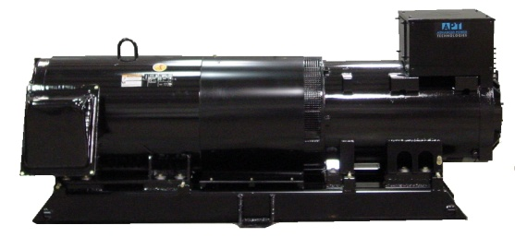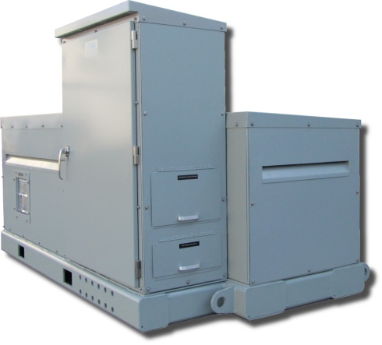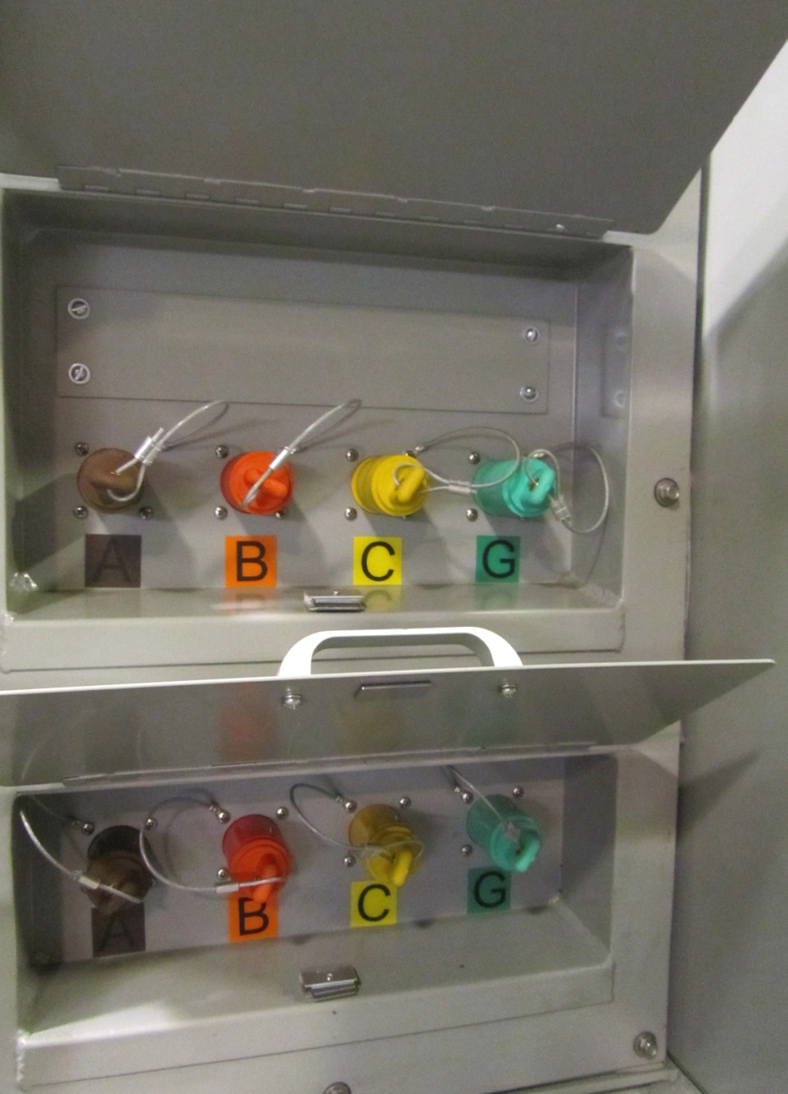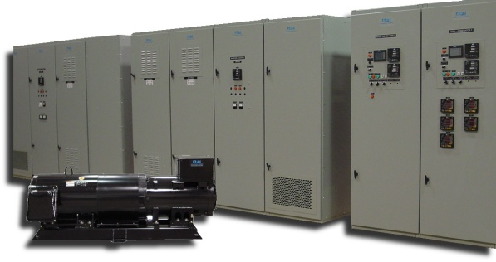APT_4C.wmf7

APT offers a wide variety of Motor-Generator Sets, Packages, & Systems that can be customized to your application and needs. It is a multi-purpose synchronous motor-synchronous generator set that allows you to use it as a 50/60Hz convertible power supply, and either a variable frequency or voltage power supply. They can be utilized in various applications such as rotary UPS, solving power quality problems, frequency and voltage converters, grid isolation, grid support devices, and micro-grids.

**Product Benefits**

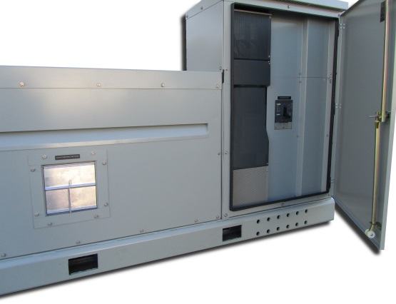

**Product Advantages**

**PROVIDING A COMPREHENSIVE APPROACH TO RELIABLE POWER**

www.apt-power.com

433 N. 36th Street

Lafayette, IN 47905

765-446-2343

**Product Limitations**

* Complete galvanic isolation between the power source and the load via mechanical coupling. This prevents the most extreme over-voltages and surges on the utility side from damaging loads connected to the generator side of the system.
* High available fault current which allows for selective time-overcurrent coordination. This increases the fault tolerance of the system and means that the short circuit in one part of the load may not affect other parts of the load. This is not achievable when traditional solid state UPS systems are used.
* Motor starting capability, which is also not achievable when traditional solid state UPS systems are used.
* Ability to operate at wide range of voltages (generally between 120 and 15,000 V) and ability to parallel unlimited number of units to achieve any kW and kVAR output.
* Proven industrial and utility grade motor and generator technology and readily available spare parts and motor/generator repair and maintenance facilities.
* Relatively low system efficiency (around 91%).
* Recommended bearing maintenance every 2 years.

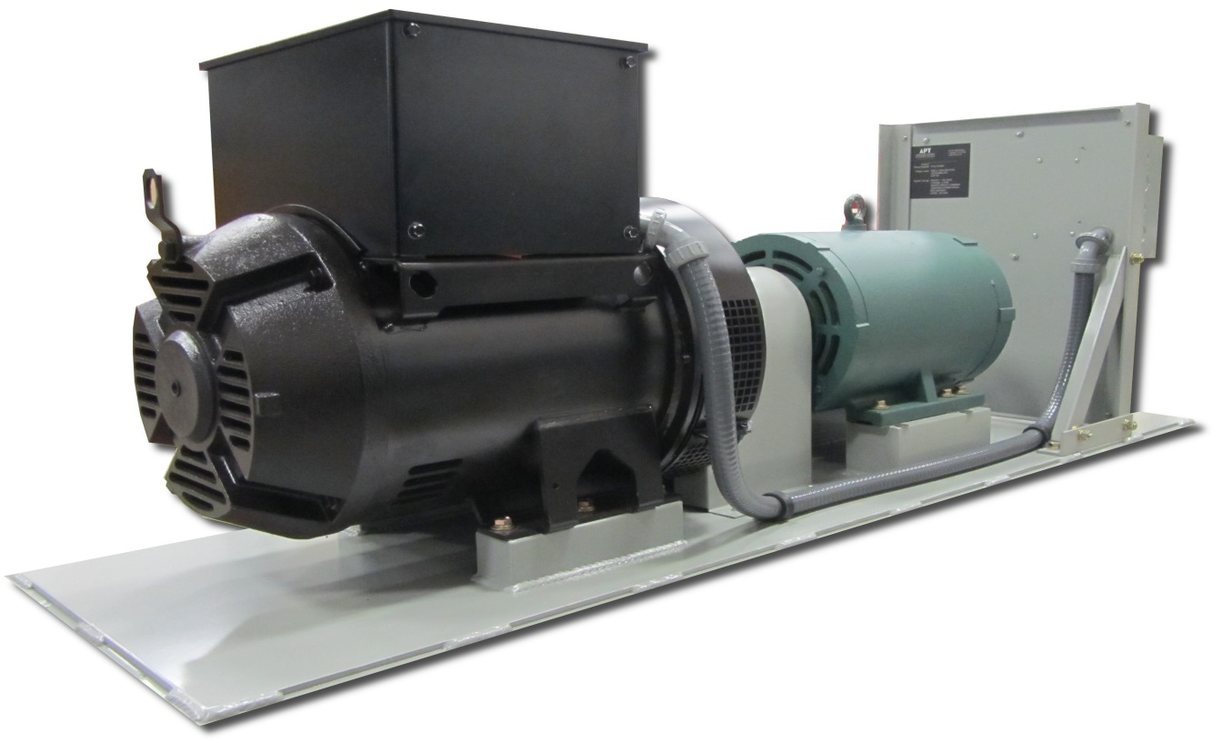

**Power Conditioning**

* Complete galvanic isolation between the power source and the load via mechanical coupling. This prevents the most extreme over-voltages and surges on the utility side from damaging loads connected to the generator side of the system.
* Ride through upon most single phase faults and sags and short three phase voltage sags which are milliseconds in duration.
* High available fault current which allows for selective time-overcurrent coordination. This increases the fault tolerance of the system and means that the short circuit in one part of the load may not affect other parts of the load. This is not achievable when solid state systems are used.
* Motor starting capability, which is also not achievable when traditional solid state conditioning systems are used.
* Ability to operate at wide range of voltages (generally between 120 and 15,000V) and ability to parallel unlimited number of units to achieve any kW and kVAR output.
* Proven industrial and utility grade motor and generator technology and readily available spare parts and motor/generator repair and maintenance facilities.

**Rotary UPS**

Motor-Generator based Uninterruptible Power Supply Systems still remain a golden standard of the Uninterruptible Power Supplies. When equipment failure due to the power surges, sudden voltage fluctuations or unplanned power losses is not an option, Motor-Generator based Uninterruptible Power Supply Systems are the answer.

**Frequency Converters**

* 50/60 Hz frequency converters
* 60/50 Hz frequency converters
* DC to 60 Hz or 50 Hz three phase converters
* Variable frequency power source
* Variable voltage power source

**Frequency/Voltage Stabilizer**

When a renewable power source can produce power with unstable frequency and voltage, APT Motor-Generator system can convert this “unstable” power in to the utility grade power source with stable voltage and frequency.

For more information about **Grid Isolation**, **Grid Support**, and **Micro-grid applications**, please contact [APT](http://www.apt-power.com/contact-apt/).

***Types & Applications***